2022 FARIBAULT HOG CHAPTER SCAVENGER HUNT!! 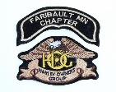

How it Works:
Ride your H-D motorcycle to a business, town, or place that ends with "Ville"...Tacoville, Waterville, MN. etc. Snap a picture of yourself with your 2022 Dealership Passport Book and "ville" in the background.
Submit your scrapbook of photos by the end of the year to Faribault Harley-Davidson.
Winners will be announced at our February 2023 Faribault Chapter HOG Gathering & Awards Ceremony.

Don’t forget to pick up your passport book from the Faribault dealership and have some fun.

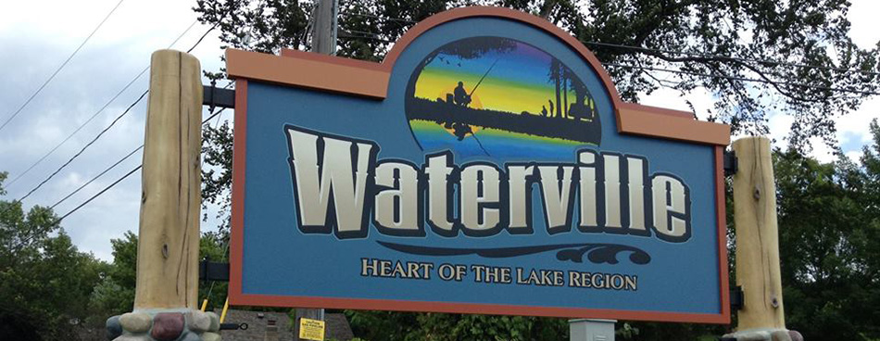

Another fun challenge for the summer would be to hit all Ann’s new dealerships!!!

