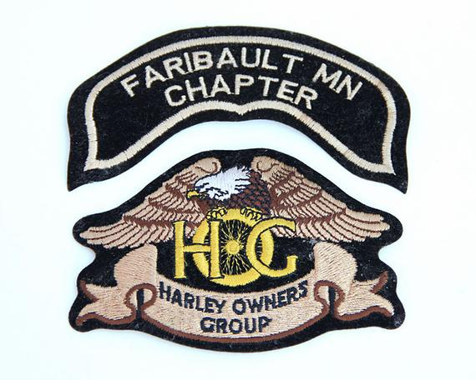
2020 FARIBAULT HOG CHAPTER SCAVENGER HUNT

This year's Chapter Member challenge is themed around HOGs! During your 2020 riding adventures, photograph as many HOGs as you can! The photos MUST include your motorcycle, you (where safe), and a pig. Hog signs, logos, or REAL Hogs, they all count! At the end of the season, print then submit your photos to the chapter officers. Entries will be judged at the end of December , then announced and awarded Gift Card prizes with the Winter Bash Party. Be creative, have fun, and please be safe! Let’s see those HOGs!

